Group-9 Project

Members:

Jay Patel - 8826636

Mohmmed Humam - 8975797​

Arshpreet Kaur - 8976131

Manminder Singh - 8973914

INFO2350-25S-SEC2

Instructor: Nikola Cedic

Due Date: 2025-08-05

Table of Contents

Task 1 Architecture Diagram 3

Description: 3

Task 2 Implementation (Manual setup of AWS Console) 4

Description: 4

Observation: 4

Step 1 : VPC and Subnets 4

Step-2 Internet Gateway and Route Tables. 6

Step-3 NAT Gateway for Private subnets 8

Step-4 Web Server Instance setup 9

Step-5 Database Server Instance setup. 11

Task 3: Automation (Using Terraform) 13

Step-1 Install Terraform and create configuration files. 13

Step-2 Initialize Terraform 18

Step-3 Plan 18

Step-4 Apply 19

Step-5 Output and verification 20

Reflection: 23

Task -4 Security Considerations 23

Security Challenge 1: Making sure that the Database is not publicly accessible. 23

Methods 23

Security Challenge 2: Accessing the EC2 over the web server. 24

Methods: 24

Security Challenge 3: Controlling the flow of traffic between EC2 and Database 25

Methods 25

Summary of Security measures we implemented 25

# Task 1 Architecture Diagram

## Description:

This diagram of an AWS architecture was designed by me with Erasure.io, a software to create cloud and network diagrams. The aim of the diagram is to demonstrate how we constructed secure and scalable cloud infrastructure to host a web application. Our design provided us with a Custom VPC, which is like our personal network operating in AWS. I decomposed this network into two sections: a public subnet with a web server, and a private network with a database server that is not exposed to the internet. I added an Internet Gateway so that the web server could access the Internet. In the case of the private subnet, I applied a NAT Gateway that allowed the database to take the updates without anyone seeing it. I also installed route tables to direct internet traffic in the correct direction, whereby the public traffic is directed through the internet gateway, whereas the private traffic is directed through the NAT gateway. I employed the use of security groups that are like firewalls, one of which would enable humans to access the web app, and the other would ensure that only the web server can reach the database. Such an arrangement ensures that our system is secure and has a future that will allow scalability.

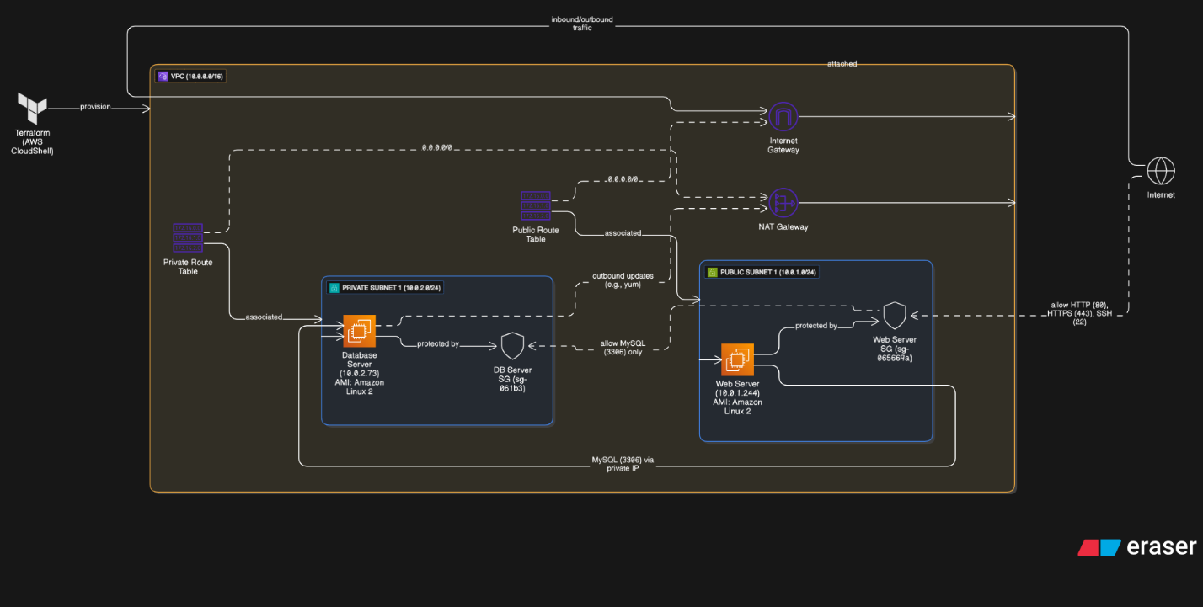

# Task 2 Implementation (Manual setup of AWS Console)

## Description:

Before deploying, we finalized Task 1’s project requirements and chose the AWS region (us-east-1) for all resources. We used the AWS Academy Learner Lab environment for testing and configurations. The key steps were creating a new key pair for SSH access and confirming that we could use the default VPC and all IAM permissions.

We then proceeded to design a customized network using the subnets, gateways, EC2 instances, and security settings required manually from the AWS Console (Task 2), and then with Terraform automation in AWS CloudShell (Task 3). The goal was to achieve a secure, scalable two-tier architecture web front-end with a private database back-end.

### Observation:

In the deployment of Task-2, we observed how all of the AWS services are interconnected i.e., how route tables, subnets, and gateways all need to be correctly set up in order for everything to work. One mistake (e.g., omitting a route or mapping the subnet incorrectly) would prevent the connectivity from working.

For the web server, deploying the correct inbound rules made it available on the internet. But for the database, putting it in its own private subnet and only test access from the web server gave us good hands-on experience with home network segmentation and firewall rules (SGs) really work.

In the automation phase (Task 3), we found it tedious to code Terraform. But afterward, it saved a tremendous amount of effort and time. Deploying 10 resources manually versus using terraform apply completely brought out the infrastructure as Code power.

## Step 1 : VPC and Subnets

We created a custom VPC and named it “ProjectVPC” with CIDR “10.0.0.0/16”.

Inside this VPC, we added 4 subnets: 2 Public (for web servers) and 2 Private (for database servers).

**Screenshots:**

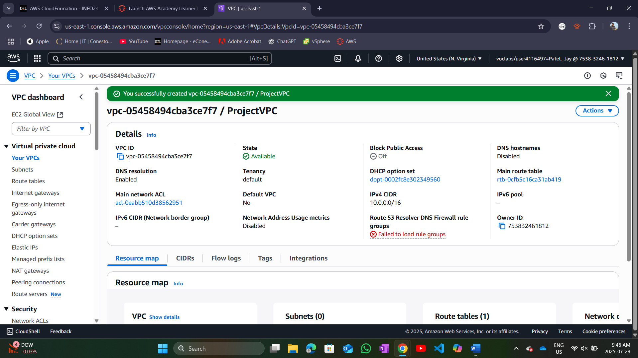

VPC created.

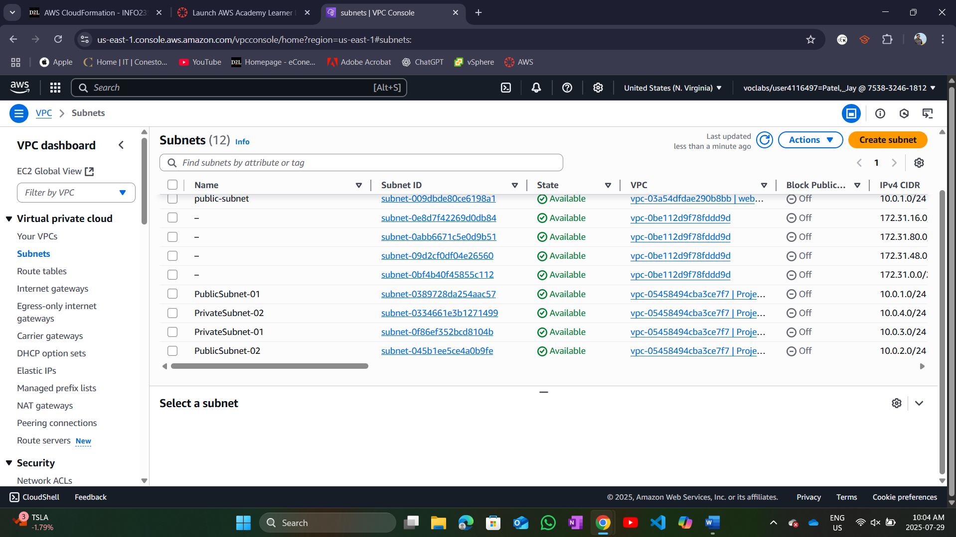

4 subnets created – 2 Public and 2 Private.

## Step-2 Internet Gateway and Route Tables.

We created and attached an Internet Gateway to our VPC.

Made two route tables: Public-RT for public subnets and Private-RT for private subnets.

**Screenshots:**

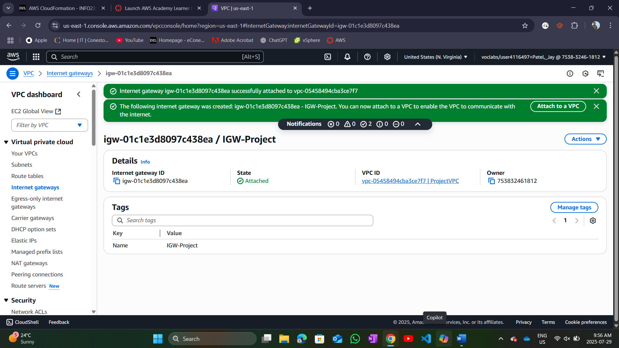

Internet Gateway created and attached to VPC.

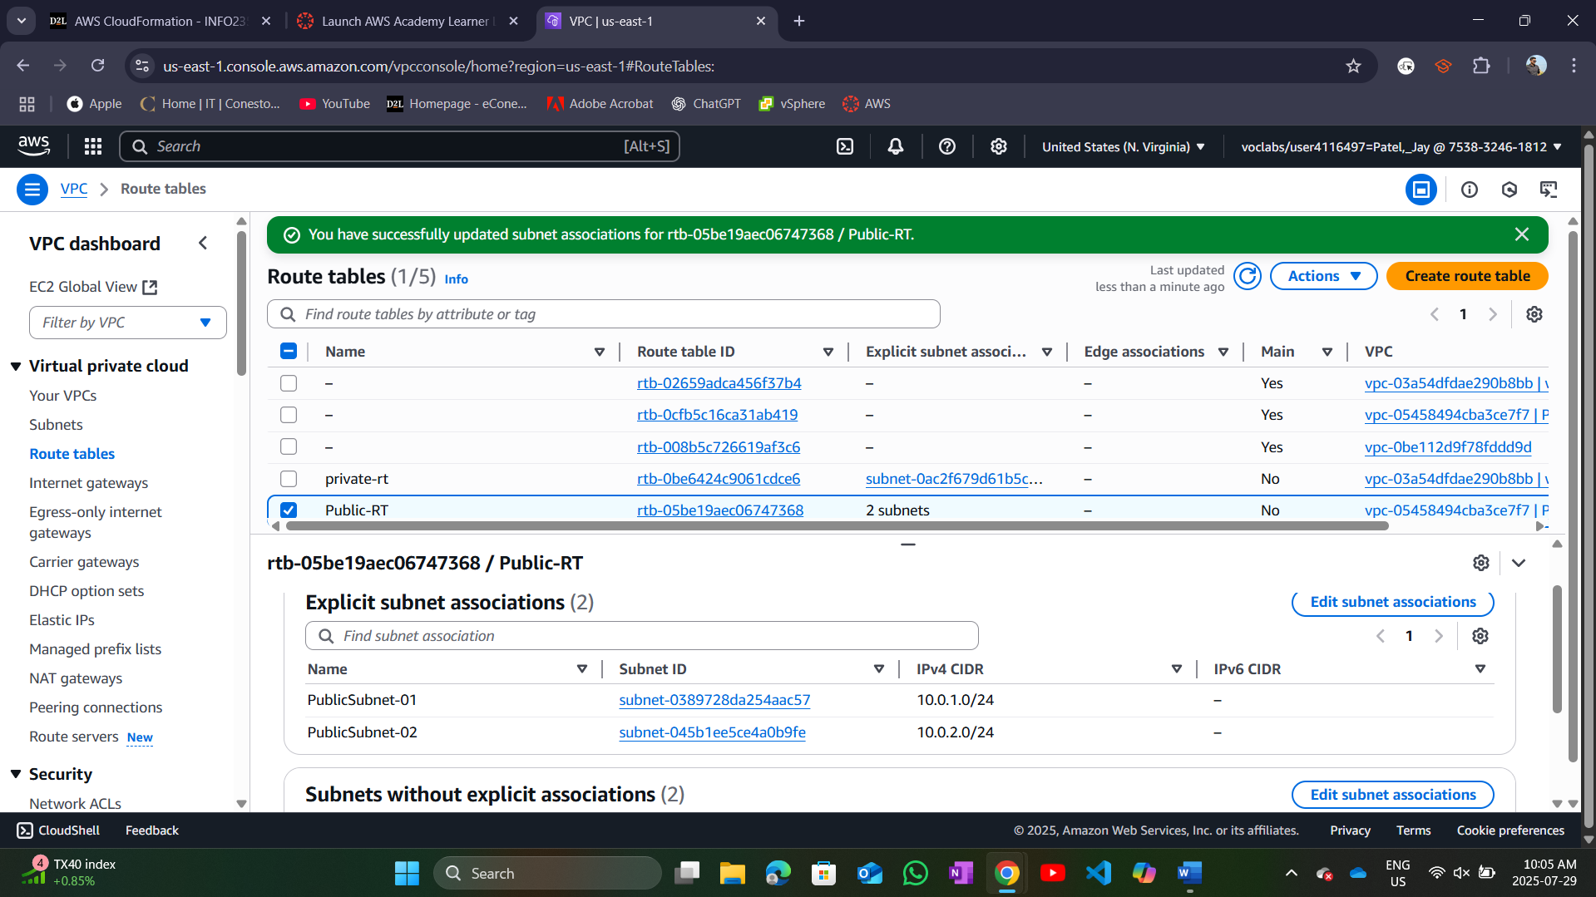

Public-RT created and associated with Public subnets.

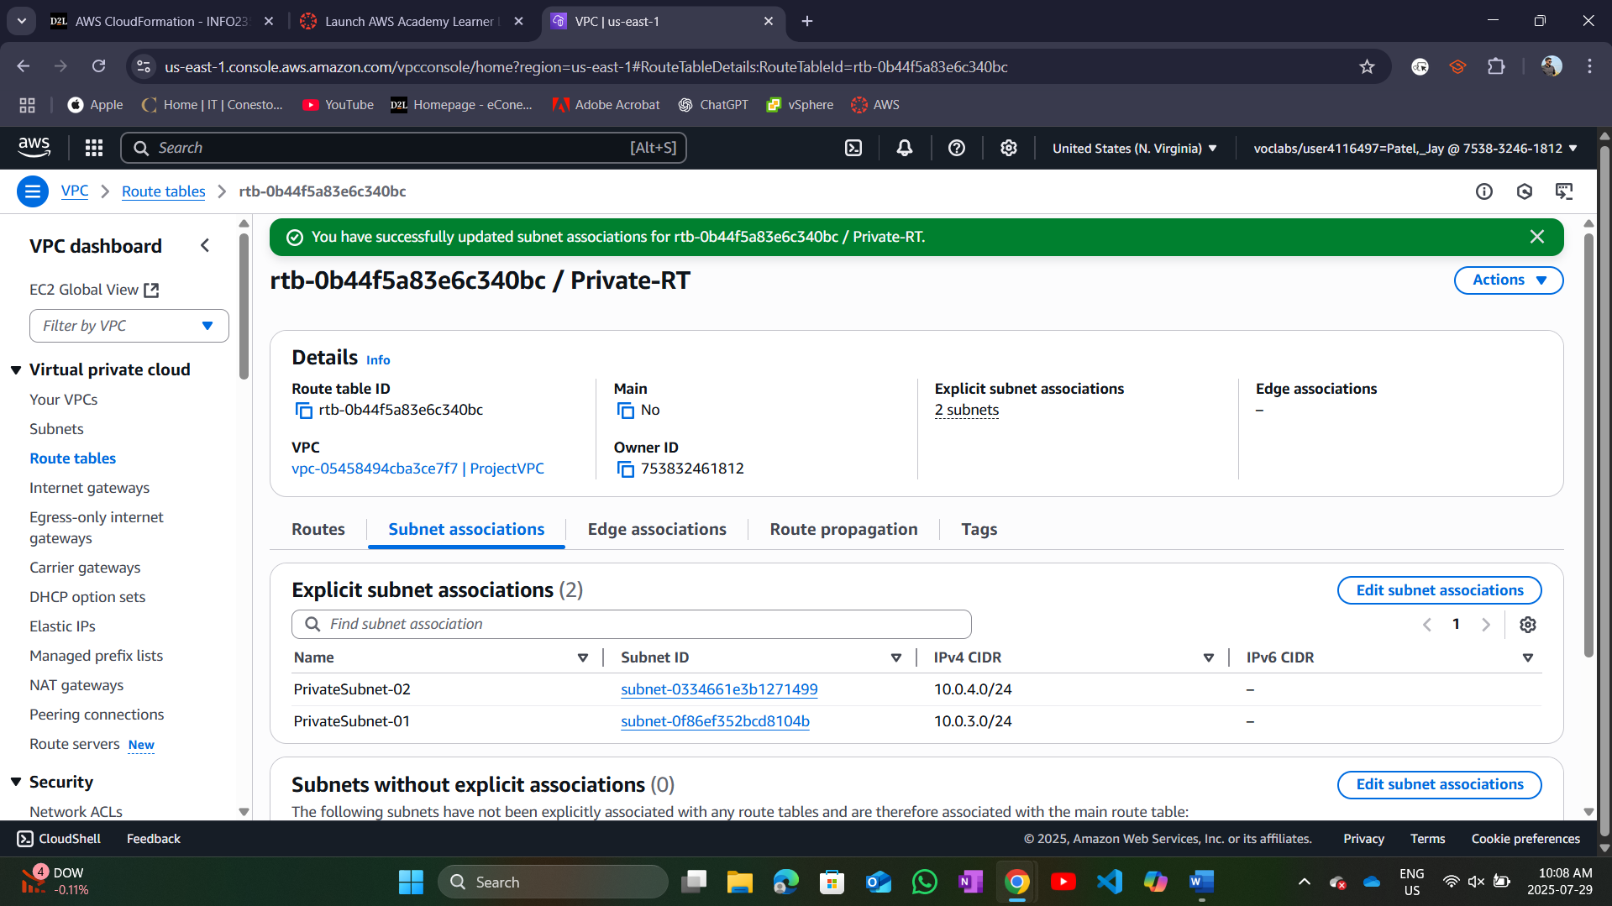

Private-RT created and associated with private subnets.

## Step-3 NAT Gateway for Private subnets

We launched a NAT Gateway inside one public subnet.

Updated Private-RT to send traffic through the NAT Gateway.

**Screenshots:**

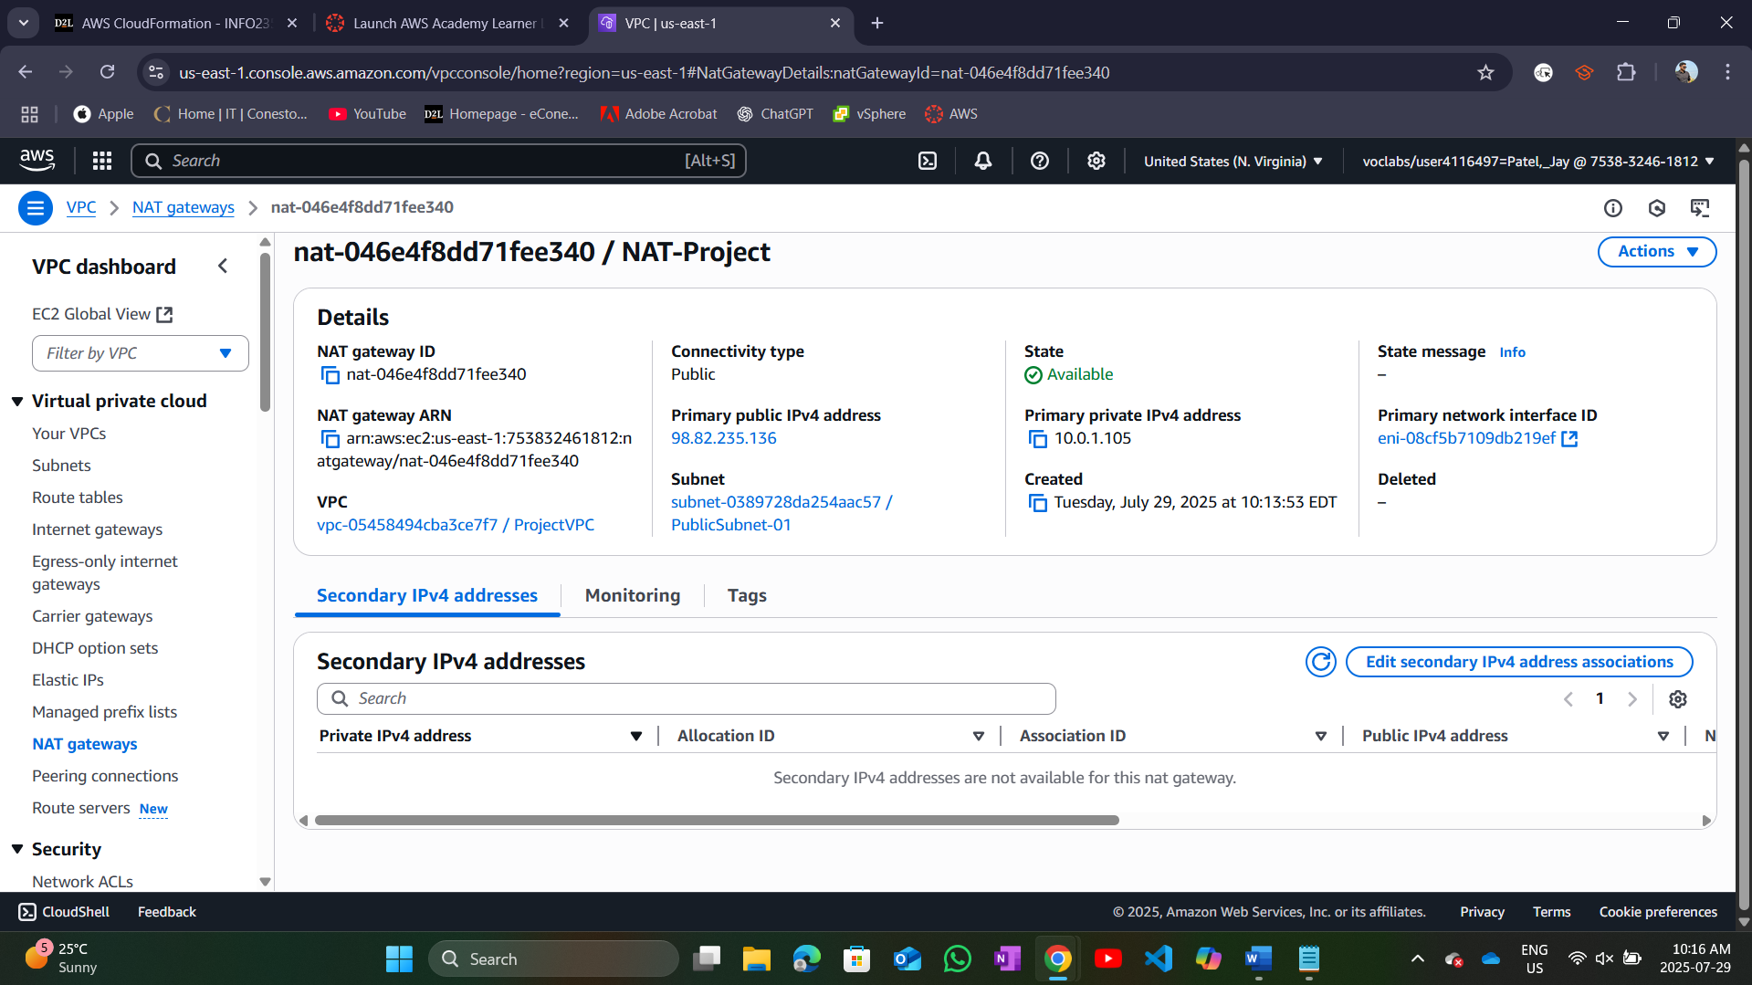

NAT Gateway created.

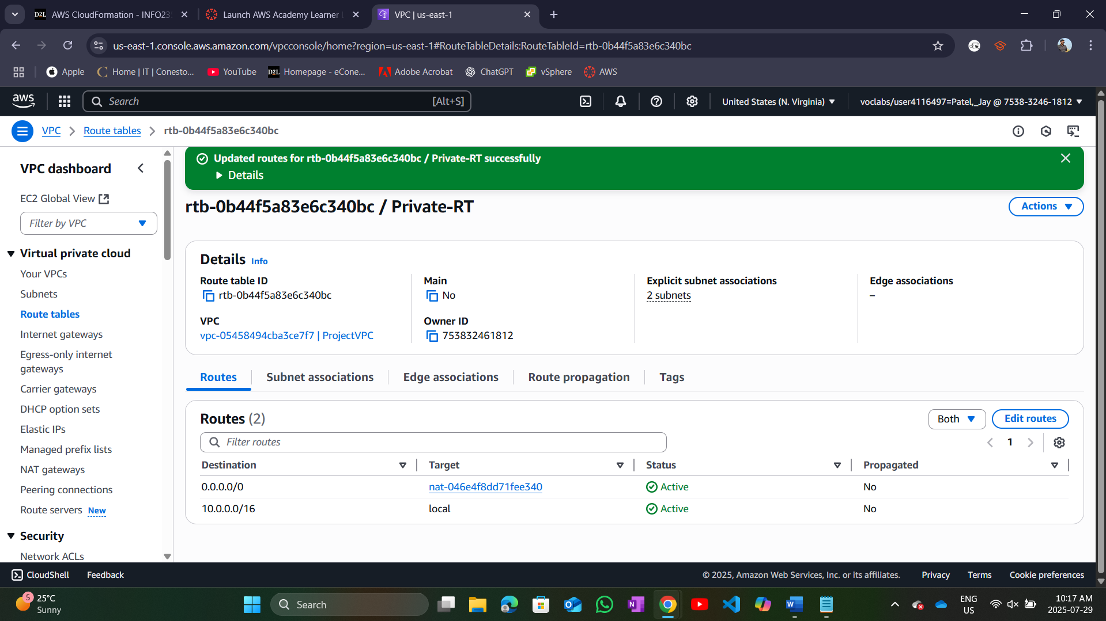

Updated Private-RT to use NAT.

## Step-4 Web Server Instance setup

Launched an EC2 Web Server in a public subnet with a public IP.

Accessed it via browser and verified the website is running.

**Screenshots:**

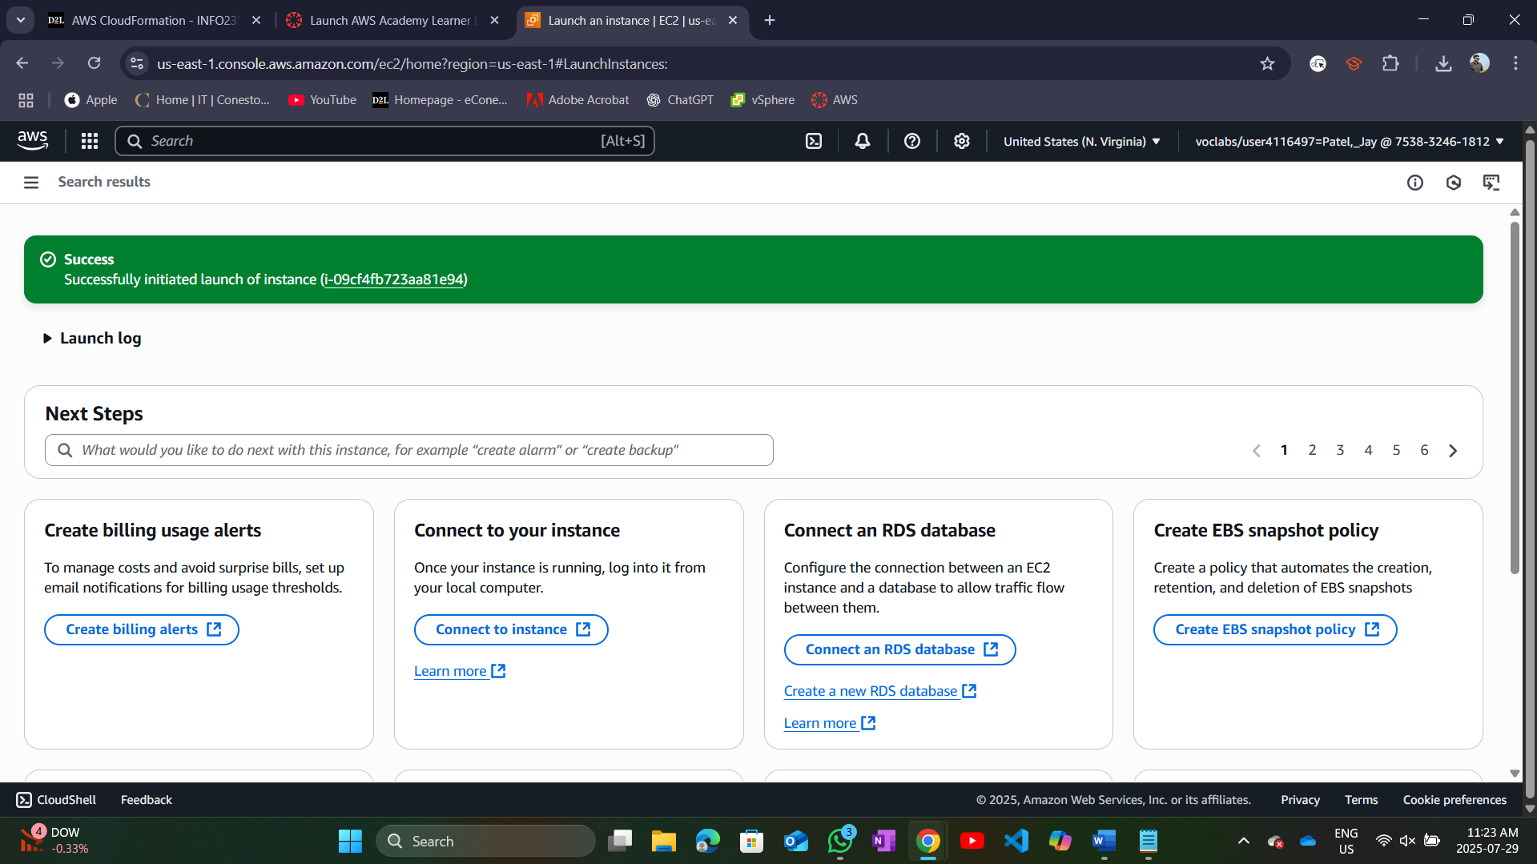

EC2 instance launched.

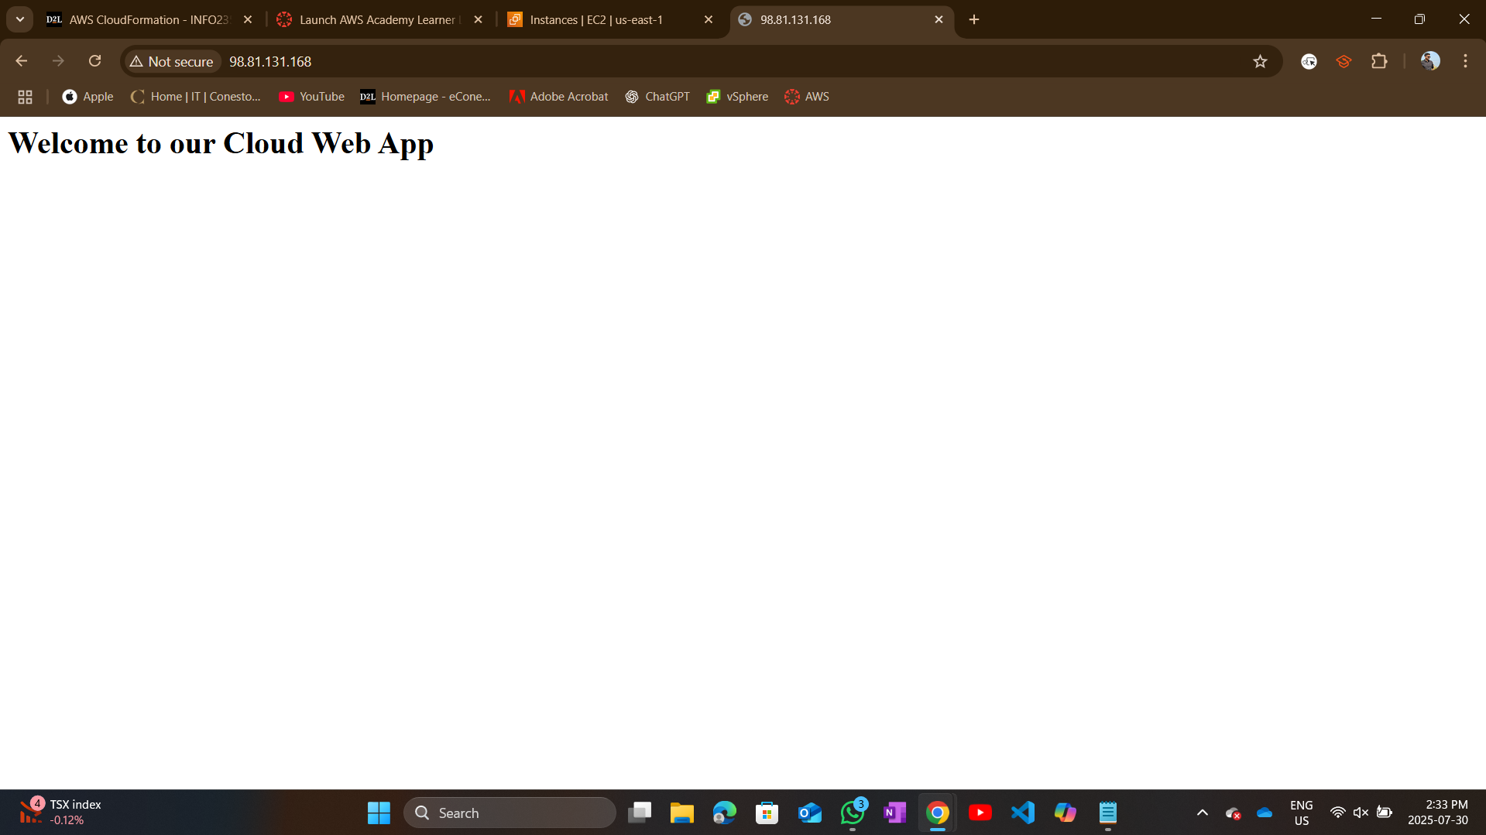

Accessed it via browser and verified its running.

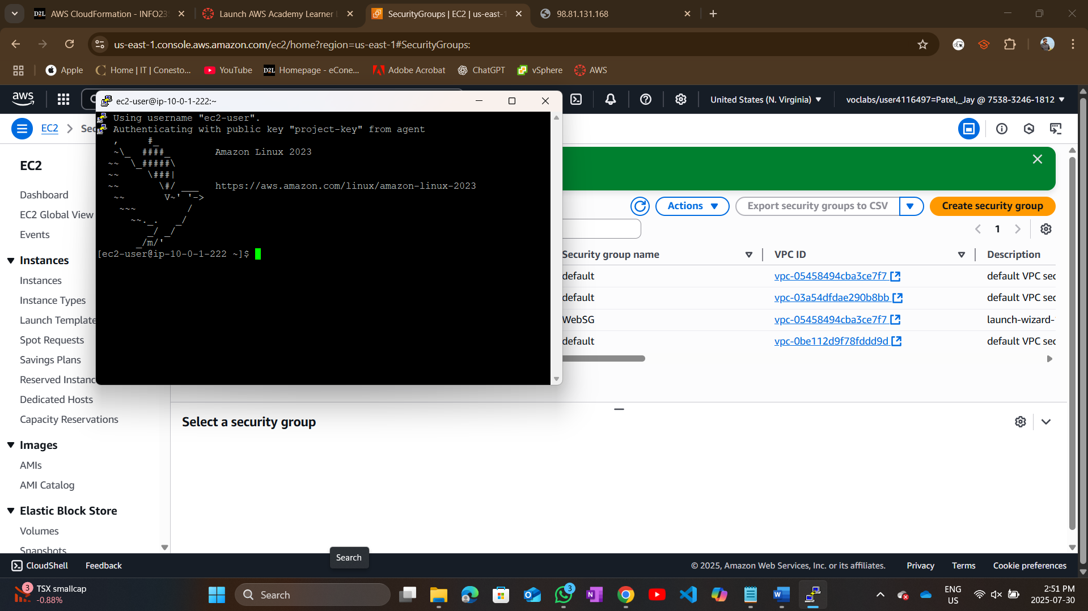

SSH connection established into putty.

## Step-5 Database Server Instance setup.

Launched a DB EC2 instance in a private subnet with no public IP.

Set DBSG to allow only web server SG on port 3306

Verified DB works using sample SQL commands.

**Screenshots:**

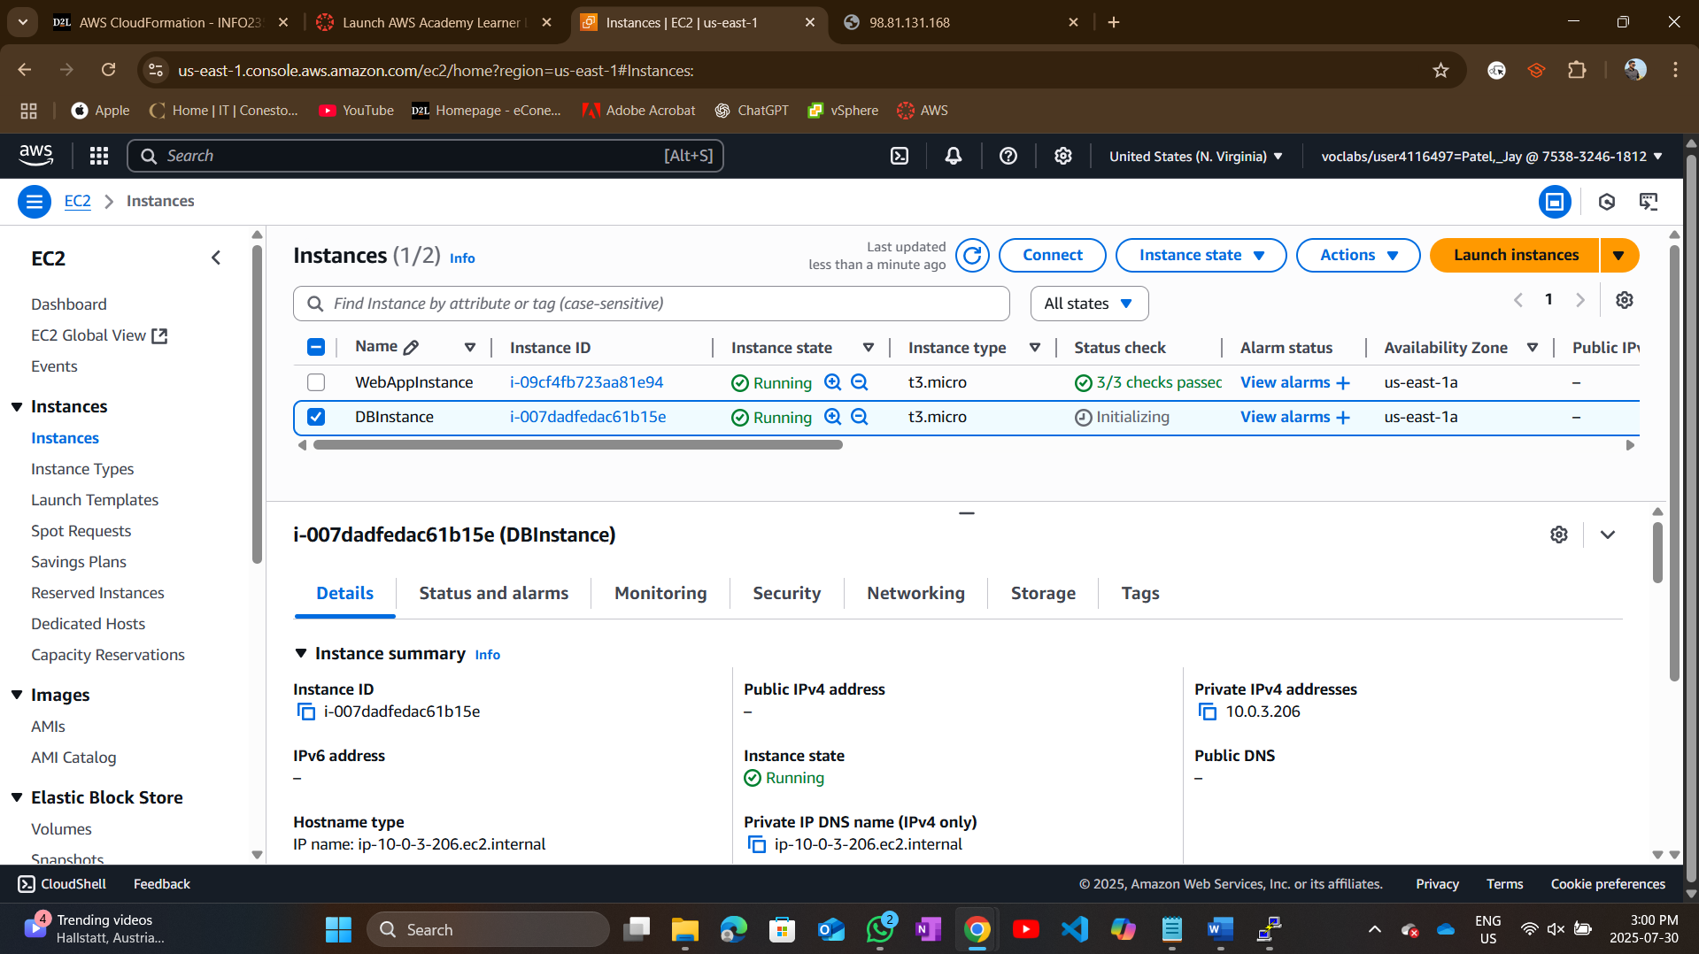

DBInstance is launched and running.

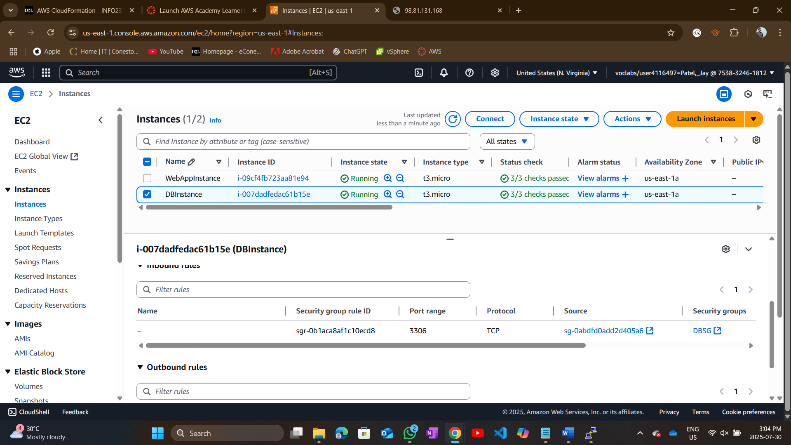

DBSG inbound rule.

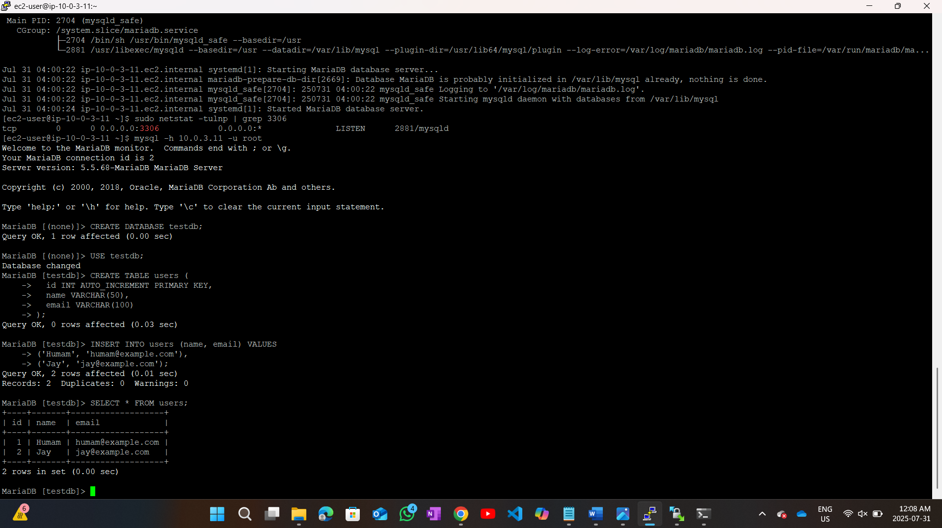

Database is working as verified after running sample SQL commands.

# Task 3: Automation (Using Terraform)

## Step-1 Install Terraform and create configuration files.

We first installed the Terraform into AWS Cloudshell to perform automation in Terraform.

We then customized and created .tf files for all the resources of implementation task: VPC, subnets, gateways, route tables, security groups, and EC2.

**Screenshots:**

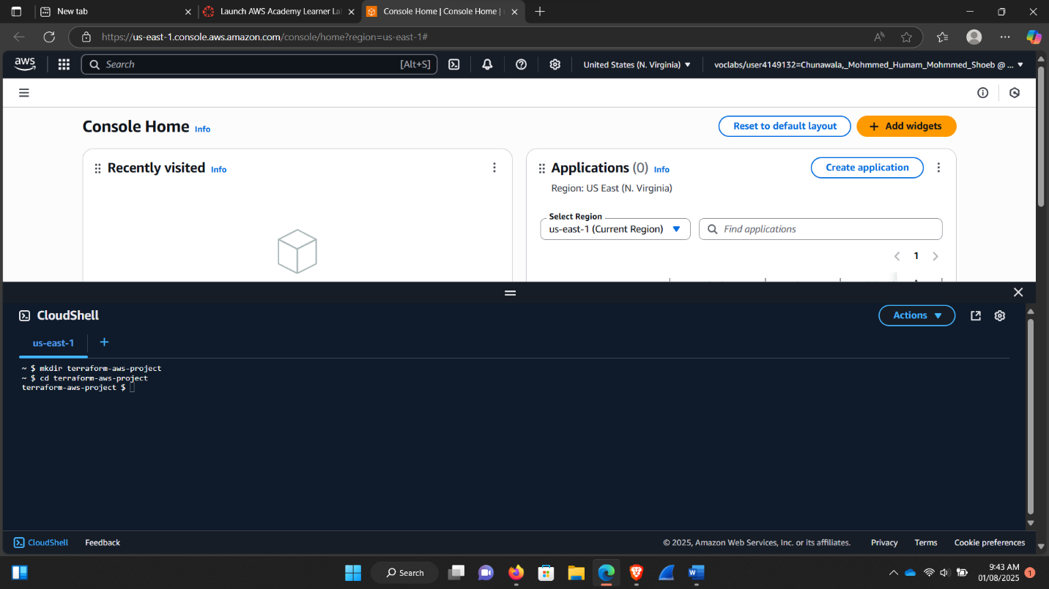

Creating AWS Project Directory

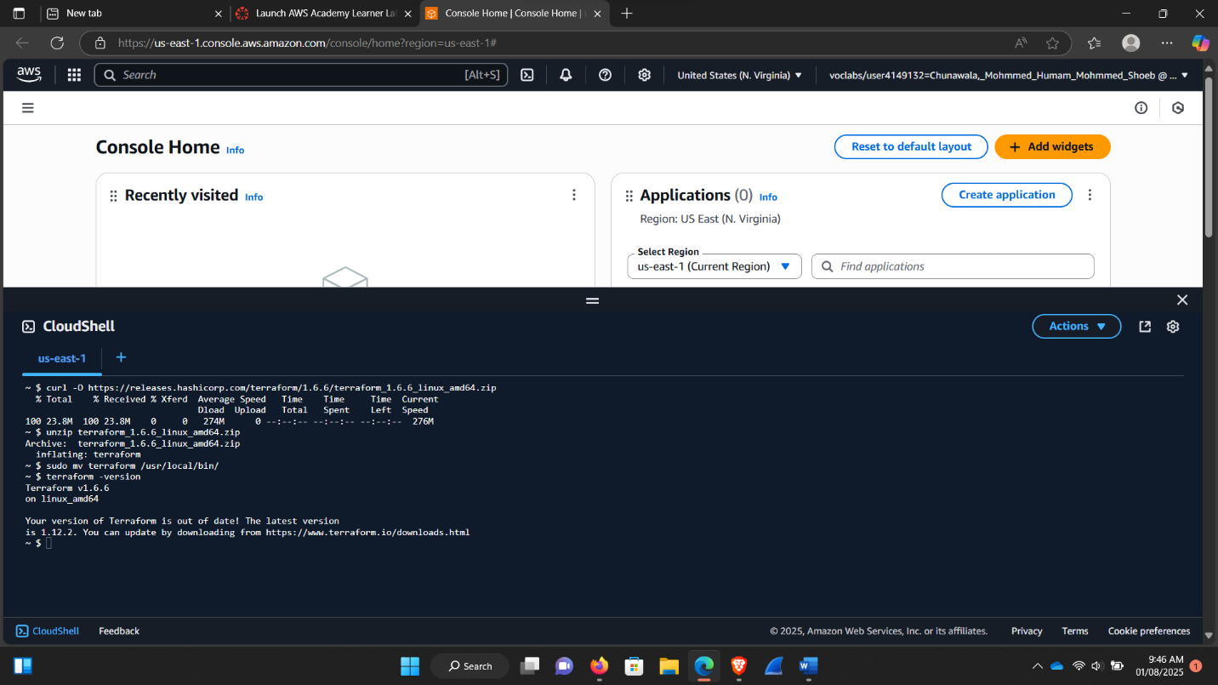

Installed Teraform manually.

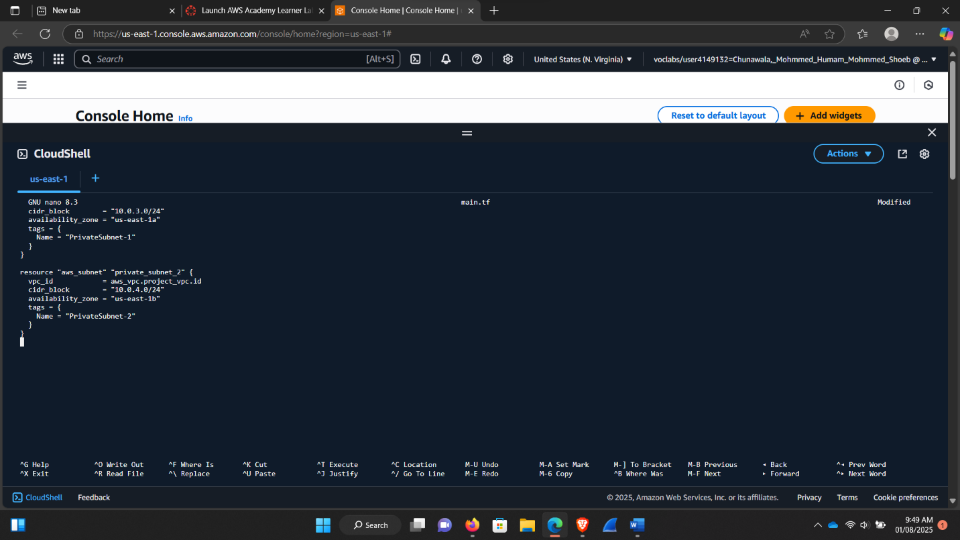

Creating VPC and Subnets.

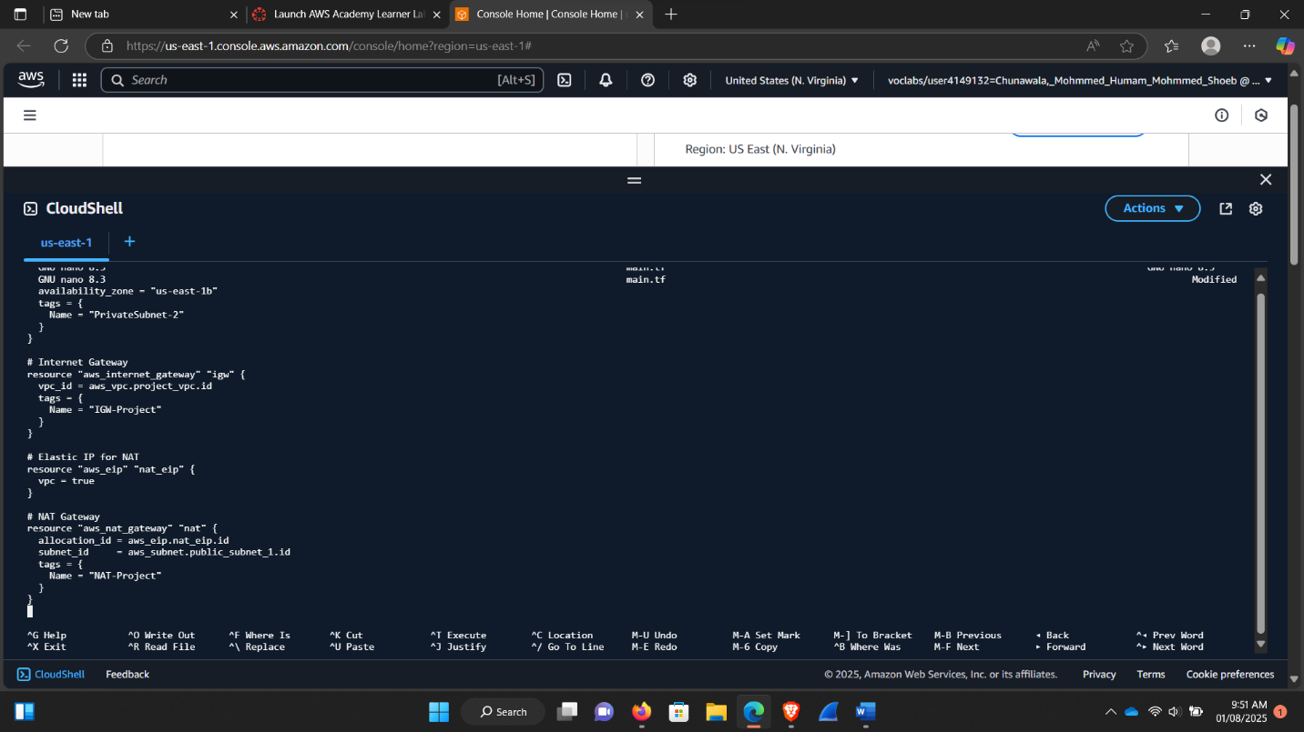

Added Internet Gateway and NAT Gateway.

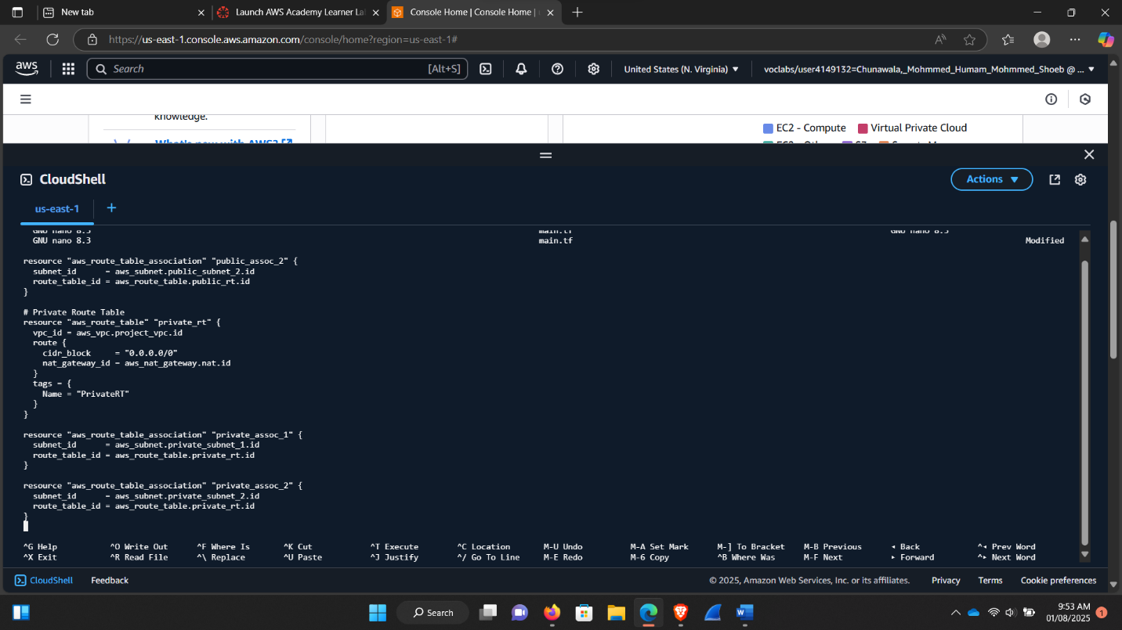

Added route tables.

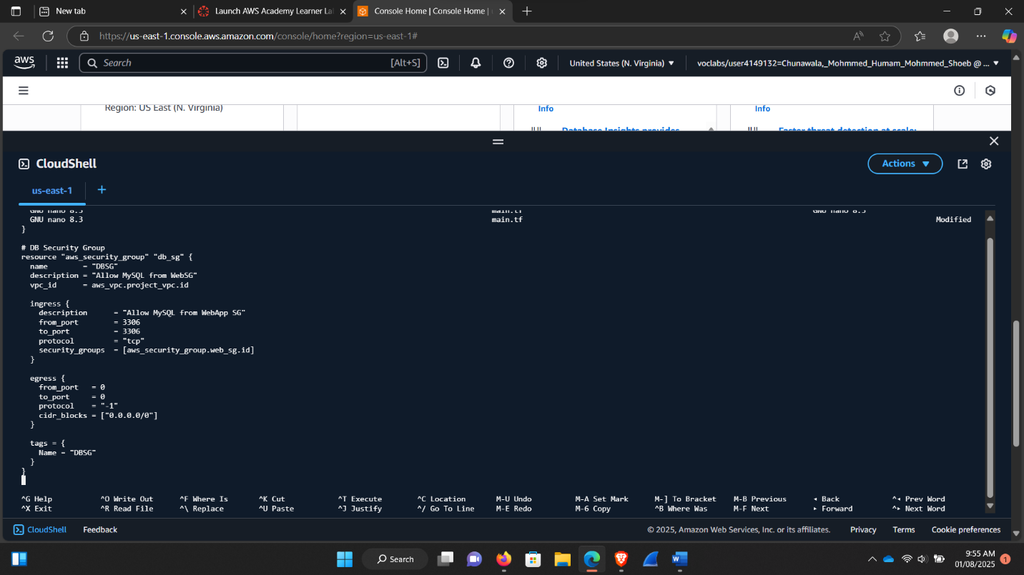

Added security groups.

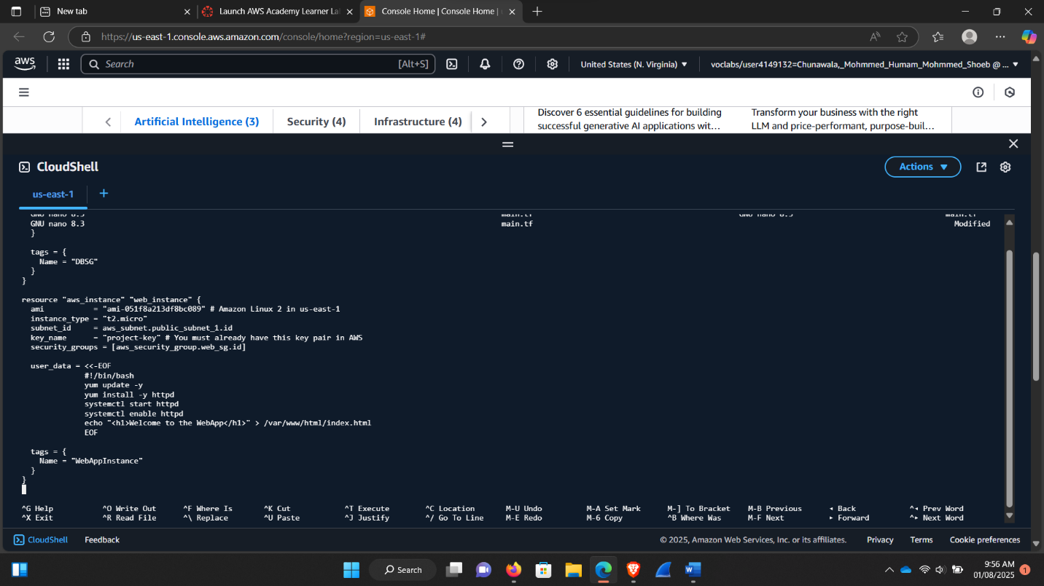

EC2 Web app Instance in public apache.

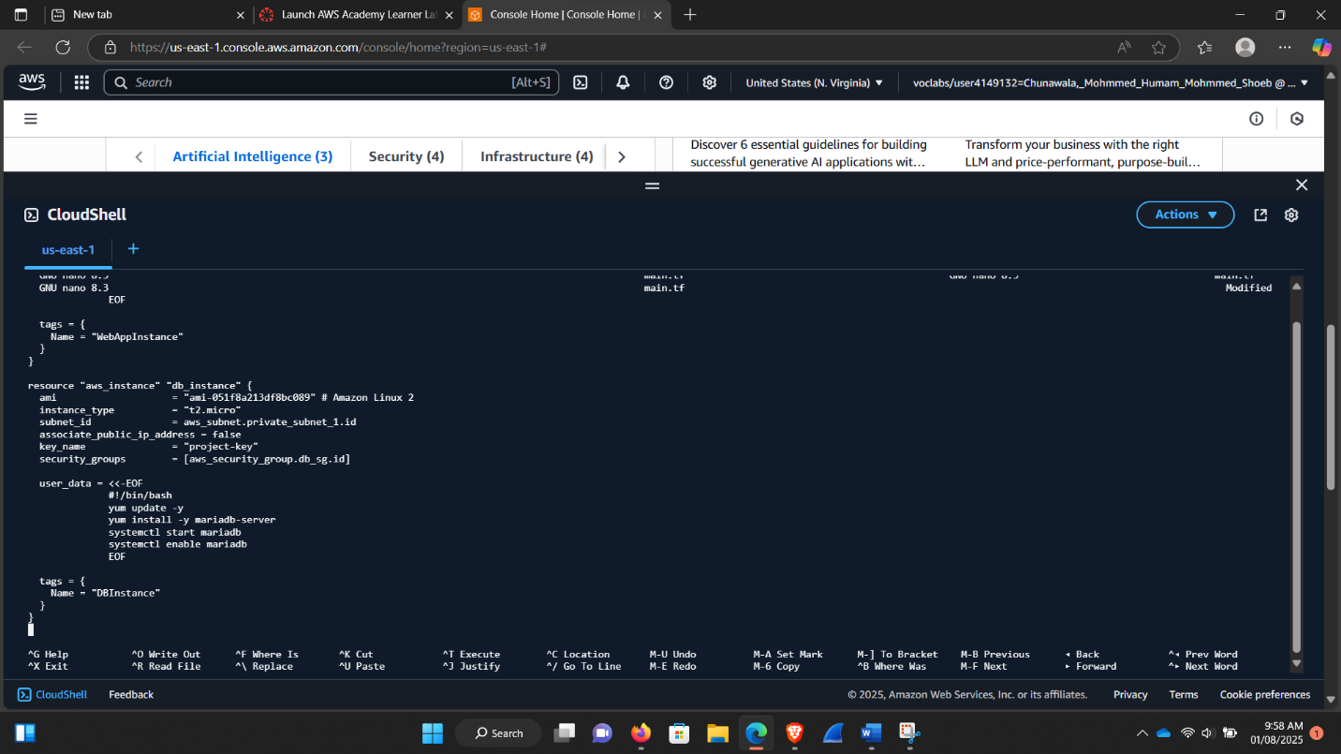

EC2 DB Instance

## Step-2 Initialize Terraform

Once .tf files were created and customized, we ran terraform init to initialize the automation.

**Screenshot:**

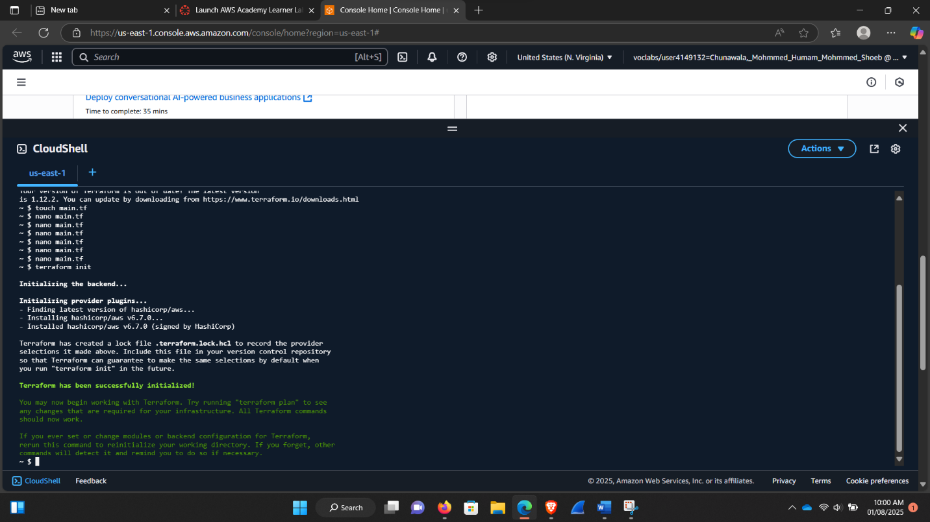

terraform.init command ran.

## Step-3 Plan

Ran terraform plan command to see changes.

**Screenshot:**

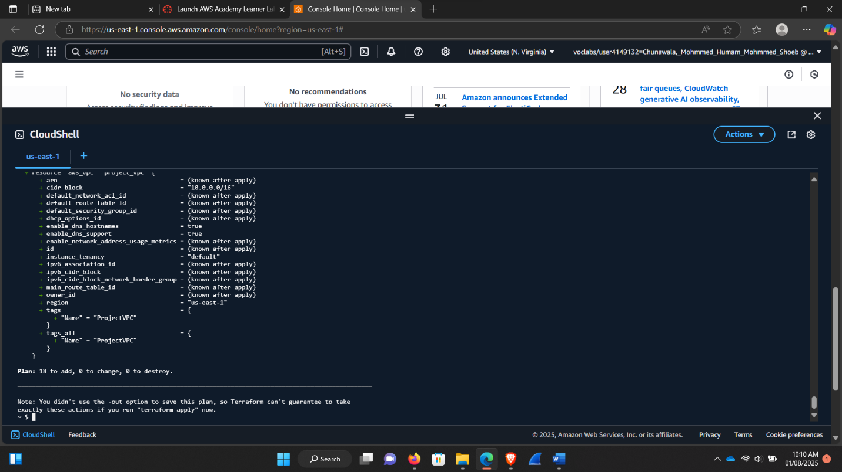

Terraform plan command worked.

## Step-4 Apply

Once Plan is done and reviewed with the changes, finally we applied it to create the infrastructure.

**Screenshot:**

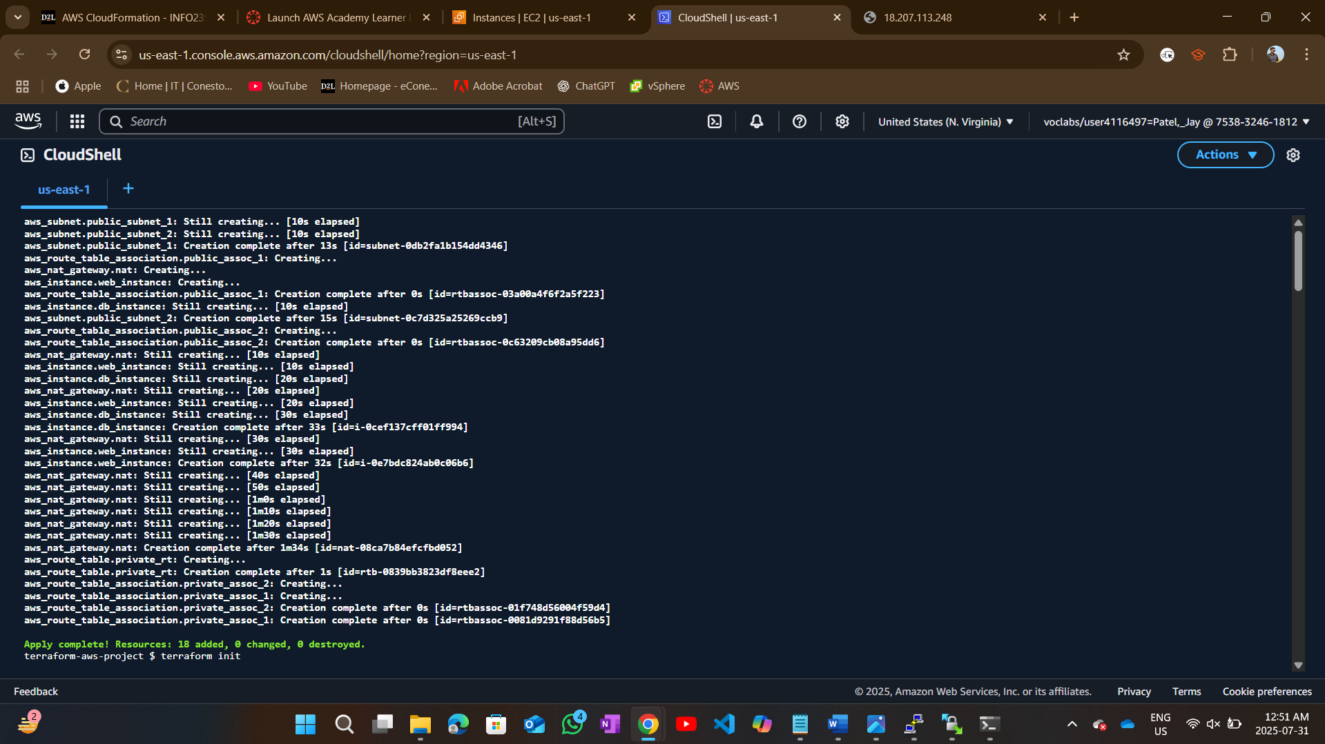

Ran terraform.apply command.

## Step-5 Output and verification

Checked outputs like IPs and subnet IDs.

Verified instance on AWS console and browser.

**Screenshots:**

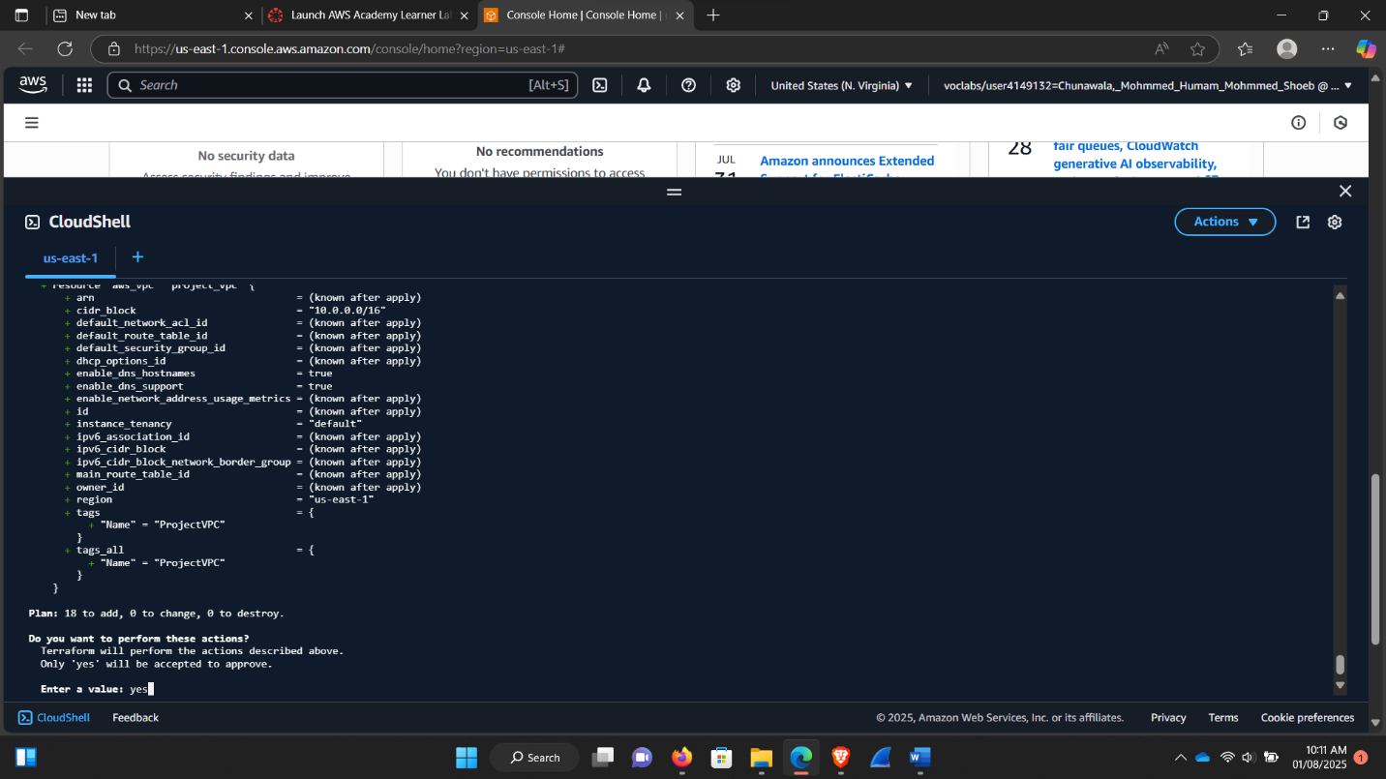

Applying terraform.apply command.

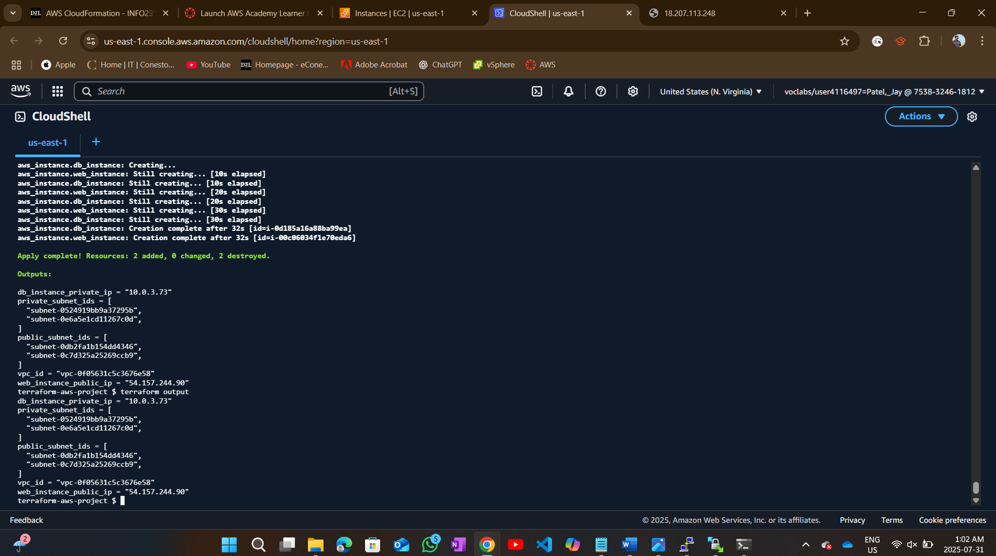

Terraform output.

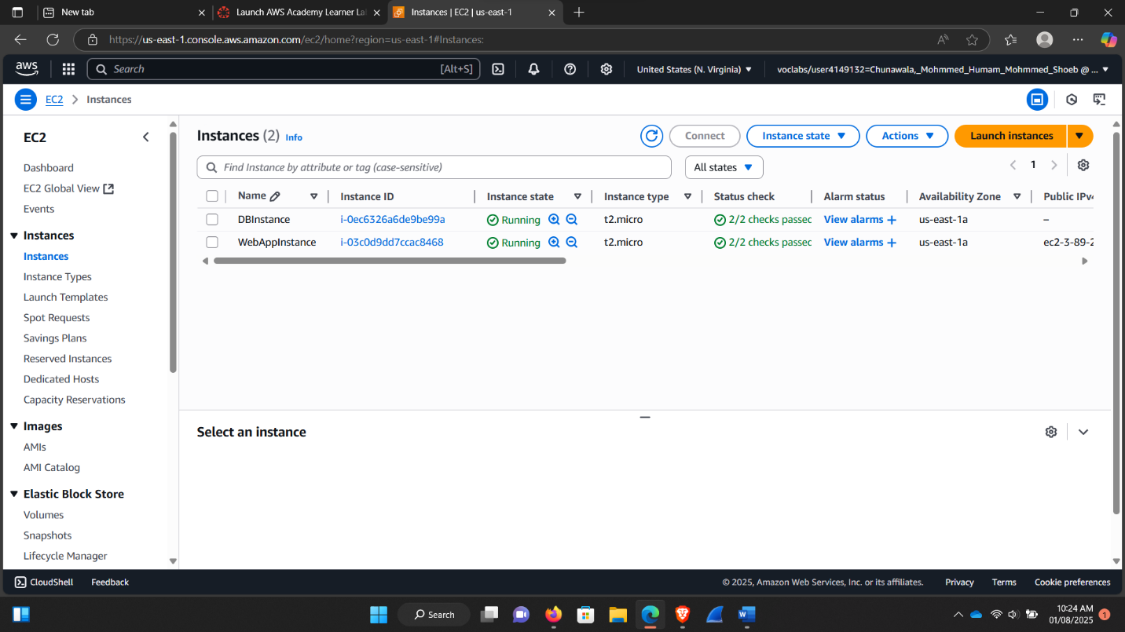

After terraform.apply command new EC2 instances can be seen running on the AWS console.

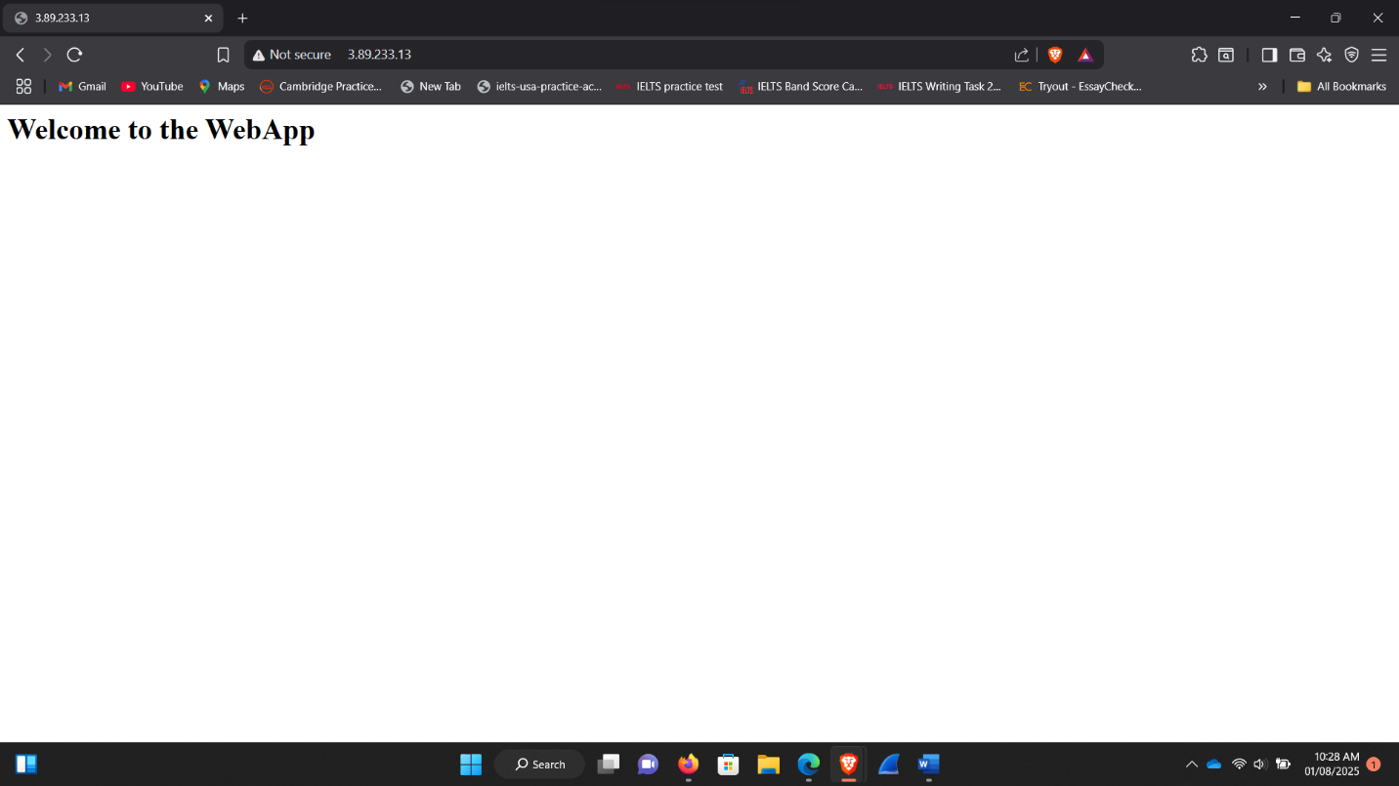

Verified via browser for the new instance that was created by automation.

### Reflection:

Overall, this project allowed us to learn the hands-on use of cloud networking. Instead of just reading theory or watching videos, we set up a real VPC with automation and security.

We also realized the importance of doing things sequentially. For example, deploying an instance before its subnet and route table is configured would lead errors. Automation made us think in terms of dependencies, what needs to be created first, and in what order things need to be.

This experience enhanced our confidence in the use of AWS and Terraform. It also helped us understand the importance of planning, testing, and documentation when working with cloud infrastructure.

# Task -4 Security Considerations

This task deals with the actual security settings we made in Task 2 and 3.

The primary goal was to make sure that the web application can be accessed through the internet and the database should be secure and within the private subnet.

## Security Challenge 1: Making sure that the Database is not publicly accessible.

### Methods

* We installed MySQL database server in a separate subnet.
* The private subnet has no route to the internet gateway, and as such, the database is not accessible on the internet.
* The security group of the database instance only allows traffic on port 3306 (MySQL) out of the EC2 instance security group.
* We made sure that the database itself was not assigned to a public IP it was private.

**Screenshot:**



Database security inbound rule.

## Security Challenge 2: Accessing the EC2 over the web server.

### Methods:

* The web application is hosted in the EC2 instance in the public subnet.
* The EC2 security group will only permit HTTP (port 80) and SSH (port 22) traffic.
* To be secure, SSH was restricted to our IP address using a small CIDR block.

**Screenshot:**

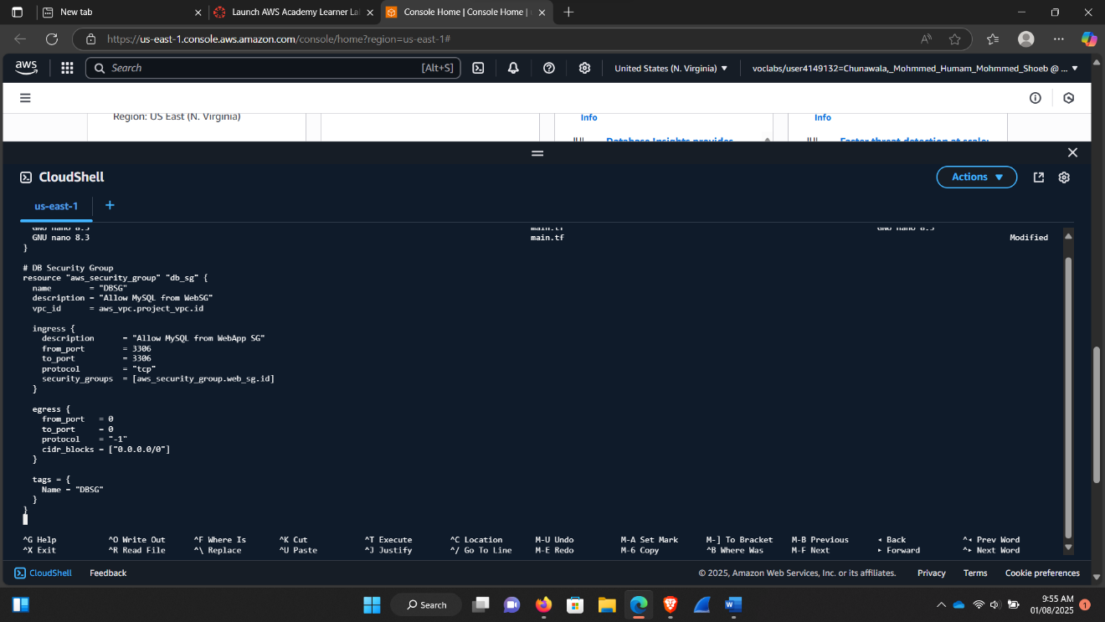

Configuration on EC2 instance for security group.

## Security Challenge 3: Controlling the flow of traffic between EC2 and Database

### Methods

* Only port 3306 is allowed to communicate between the database and EC2.
* The security group on the database is configured to accept only the EC2 security group.
* No other traffic can access our database.

## Summary of Security measures we implemented

|  |  |
| --- | --- |
| **Security setup** | **Security Setup based on task 2 and 3** |
| Database | Database No public IP. Only internal subnet (no access to the outside world). Security group permits only from EC2 Security group. |
| EC2 Instance | It’s in Public Subnet, security group opened to http from any location, SSH access is restricted only the IP of the administrator can access it. |
| Communication | Communication Port 3306 EC2 Security Group to Database Security Group, no traffic opened elsewhere. |